**Write a C program to search a number using Binary Search method**

**INPUT:**

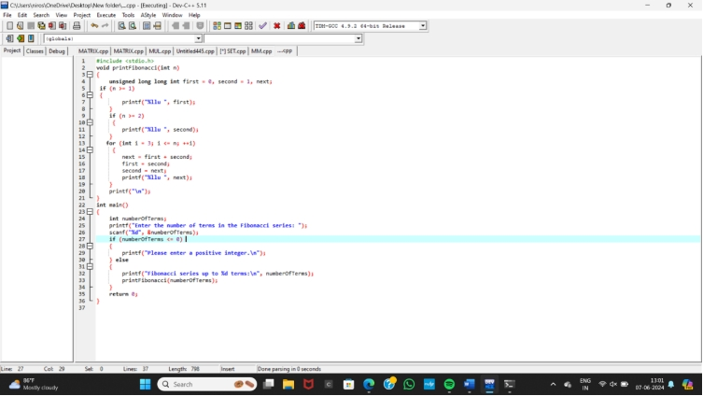

**OUTPUT:**

